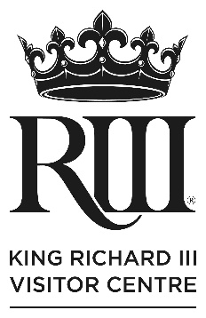
King Richard III Visitor Centre
Sleepover Packages
We have two packages available to choose from:
Standard sleepover
Cost per child: £30
Cost per adult: £10.50

This includes:
- Hot dinner of pasta bake, apple crumble and squash/water
- Hot chocolate before bedtime
- Tea/coffee available for adults throughout the sleepover
- Breakfast of bacon or sausage rolls, cereal, tea/coffee, squash/water
- Entry to the exhibition
- Sleeping areas within the galleries
- Use of laptop, projector and sound system to show film
- Risk assessment
- Free familiarisation pre-visit and safety briefing for leaders
- Two Visitor Centre staff on site all night
There must be a minimum of 25 children, not including adults/leaders and we can accommodate a maximum of 100 people in total, including all adults and children.
We require a minimum of one adult per eight under 12-year olds and one adult per 10 under 15-year olds.

Medieval Feast sleepover
Cost per child: £40
Cost per adult: £17

This includes:
- Three-course medieval feast for dinner:
Vegetable potage (soup)
Honey roast chicken, served with peas and carrots, cabbage, roast parsnips, bread sauce
Frumenty (spiced rice pudding with raisins)
- Hot chocolate before bedtime
- Tea/coffee available for adults throughout the sleepover
- Breakfast of bacon or sausage rolls, cereal, tea/coffee, squash/water
- Entry to the exhibition
- Sleeping areas within the galleries
- Use of laptop, projector and sound system to show film
- Risk assessment
- Free familiarisation pre-visit and safety briefing for leaders
- Two Visitor Centre staff on site all night
There must be a minimum of 25 children, not including adults/leaders and we can accommodate a maximum of 60 people in total, including all adults and children.
We require a minimum of one adult per eight under 12-year olds and one adult per 10 under 15-year olds.
Sleepovers must take place within closed hours, i.e., after our daytime closing time of 4pm or 5pm, depending on day of the week and time of year and before opening time the following day at 10am.
For more information, call our booking team on 0116 229 4132 or email: groups@kriii.com

