Teachers Information Pack

Thank you for your interest in bringing your group to visit the King Richard III Visitor Centre.
This pack has been developed to help you get the most out of your visit. Where possible, we recommend that this pack is made available to all teachers who will be present on your visit.
We look forward to welcoming your group to the Centre.

Contact the Learning team on 0116 229 4132 or schools@kriii.com

Contents
General Information 1
Exhibition Information 4
Risk Assessment 9
Floor Plans (showing fire exits) 11

COVID Secure
We have consulted the Department for Education guidelines and the Space for Learning guidelines in making our venue safe for school groups to visit. We hold the Visit Britain ‘Good to go’ accreditation and the Learning outside the Classroom Quality Badge, which now includes a COVID-19 Secure declaration.
Our risk assessment on page 9 contains details of the provisions we have put in place to prevent infection. If you would like to conduct your own risk assessment before bringing your group, please do contact us on 0116 229 4132 or schools@kriii.com

General Information
Booking confirmation
Please complete and return the Booking Confirmation form to our Bookings Coordinator within three weeks of making your provisional booking.
Please note that if you wish to visit Leicester Cathedral as part of your day, you must book in advance. We can arrange this with the Cathedral on your behalf.
Familiarisation
Once you have a provisional/confirmed booking with us, you can book a free familiarisation visit. This is free for the teachers who will be leading your group on the day of your visit. Any additional family or friends will be charged normal admission rates. To book your free familiarisation, please call us on 0116 229 4132 or email on schools@kriii.com. If you are unable to attend a familiarisation visit, we recommend that you examine our risk assessment and floor plan carefully and acquaint yourself with the fire exits.
Lunch arrangements
If you haven’t already made lunch arrangements, the King Richard III Visitor Centre does have a room which can be booked by schools. However, this space is in high demand, so we recommend that you check availability with us when you make your booking. Alternatively, the Cathedral Gardens are immediately opposite the King Richard III Visitor Centre and are free to use for picnics in good weather.
Discovery Packs
We provide ‘Discovery Packs’ for school children to use during their visit. These are one double-sided sheet of A4 and are available in KS1 and KS2. These will be ready for you to pick up and use when you arrive, along with clipboards and pencils. You can see a preview on our website on the Planning your visit page.
Facilities
The Visitor Centre’s toilets are located at the back of the building.
Ground floor:
Female WC (three cubicles), one self-contained unisex toilet, one self-contained accessible toilet
First floor:
Male WC (one cubicle and three urinals)
These toilets are also used by the general public. You are welcome to make use of the unisex and accessible toilets for boys, so that all children can use the toilets on the ground floor.
The visitor centre can provide storage for coats and bags whilst your group visit the exhibition. Please let us know if these need to be kept in a secure area.
What to expect on arrival
We will meet your group at the coach drop-off point on Southgates and escort you to the Visitor Centre entrance. Please be ready to confirm the total amount of children and adults in the group. If you are being invoiced after your visit, these are the numbers which we will use to raise the invoice. If you are paying on arrival, please ensure that you allow an extra five minutes for the process of payment.
A member of our staff will spend a few minutes introducing you to the site and the exhibition. Children will then enter the exhibition in groups of up 25 at a time, to prevent overcrowding.
Feedback
We would love to hear about your experiences at the King Richard III Visitor Centre and would welcome any feedback you can provide. Please collect one of our school visit feedback forms from the Admissions desk when you arrive and return it to us using the accompanying SAE. Your feedback is really valuable and helps shape our learning offer.
Gift shop
Space in our gift shop is limited, so we encourage you to visit in small groups. Alternatively, you can pre-order gift bags for children, each containing a selection of items from the gift shop, ready to collect on the day. Please contact us for options.
Ground rules
Please do not eat or drink in the exhibition.
Photography is fine, we ask that you turn the flash off

Exhibition Information

Gallery 1 – ground floor
In the first part of the exhibition, you will meet 5 people who knew Richard in his lifetime;
- Richard’s mother, Cecily Neville, who tells you a little bit about what life was like for Richard when he was growing up.
- Richard’s cousin and guardian the Earl of Warwick, (Warwick the Kingmaker), whose house Richard went to live at when he was a bit older.
- Vincent Tetulior who made Richard’s suit of armour, he tells you what Richard was like as a soldier.
- Anne Neville who was Richard’s wife and also daughter of the Earl of Warwick.
- King Edward IV, who was Richard’s older brother and was the King before him.
Each of these people will tell you a bit about Richard.
The throne is a replica of what the medieval throne of England looked like, with a replica Stone of Scone underneath.
The map on the right of the throne shows all the battles of the War of the Roses.
The family tree on the left of the throne shows the two Houses of York and Lancaster and their common ancestors, King Edward III and Queen Philippa.
Gallery 2 – ground floor
The timeline explains the events following the death of Edward IV and how Richard became king.
The Princes in the Tower – the fate of Edward IV’s young sons is explored in an interactive game. This can become busy, so it might be worth encouraging pupils to re-visit this later.
Richard’s table of achievements gives more information about what he managed to achieve in his short reign.
- Richard passed laws ensuring people had a fair trial when they went to court, even if they were poor. He set standards to make juries fairer and prevented the accused from having their property seized before they were proved guilty
- Richard made sure that all books and laws were written in English, not French or Latin, so more of the common people could read them.
- Richard made sure all weights and measures were the same so people didn’t get cheated when trading
- Previous monarchs had ‘encouraged’ wealthy subjects to give money to the crown to fund expenditure on wars or other expensive undertakings. Richard stopped asking people to give money to the throne, and started a system of loans instead.
Lord Stanley’s involvement in the battle of Bosworth was decisive, the swinging sword shows how Stanley’s allegiance shifted between King Richard and Henry Tudor.
The heraldry doors contain information about the main people involved in the battle of Bosworth and gives more information about medieval warfare.
The three films give an impression of the battle of Bosworth, beginning with the battle itself, followed on the next screen by Richard’s last stand, then the burial at Grey Friars, after Richard’s body had been carried back to Leicester
The corner display gives quotes from contemporary descriptions of the battle and Richard’s last moments. All contemporary sources agree that Richard fought bravely to the end.
When you leave this part of the exhibition, continue upstairs to find out the rest of the story. Toilets are located here, girls on the ground floor, boys are up the first flight of stairs.
Gallery 3 – first floor
The portrayal of Richard III through history has been largely influenced by Shakespeare’s play. In the play, Richard is shown as a villain, twisted and deformed and guilty of murder; others have suggested that he was a good and loyal king, and that he has been subject to slander and propaganda by the Tudor court.
Richard’s disability has been revealed now his remains have been found. Medieval attitudes to disability are very different to our attitudes today, we know that someone’s body shape does not reflect their character. Other successful people with similar disabilities show that Richard’s scoliosis may not have been the terrible impediment that Shakespeare described.
The glass balcony allows you to see Leicester Cathedral to your right, this is where Richard will be reburied in March 2015. You can also see the remainder of the Social Services car park, where the dig took place and the grave site, (the gold roofed building on the other side of the stone wall). There should be no more than 6 people on the balcony at any one time, visitor centre staff will help monitor this.
The virtual reconstruction of the Grey Friars complex shows what a typical medieval Franciscan friary would have looked like, with the church on one side oriented east to west. The virtual flythrough shows the interior of the church with Richard’s tomb in the choir area, with the head pointing west.
The Dig Diary takes you day by day through the excavation of the Grey Friars site and the interactive screens in this area have interviews with the main people involved, (including Philippa Langley, Richard Buckley, John Ashdown-Hill, Matthew Morris and others).
Gallery 4 – first floor
The archaeological game contains actual finds from the dig, mostly medieval pottery, and shows the different layers in the ground that the team had to dig through to find the grave.
The suit of armour is an example of what Richard might have worn at the Battle of Bosworth. Battle armour weighed in at about 15-25kg, and allowed for very good movement, as it is constructed from many overlapping plates. The plates on this suit are numbered to help you identify the parts and find out more about each piece from the display.
The medieval weapons which probably killed Richard in the battle are shown here with information about how they would have been used on the battlefield.
A 3-d model of Richard’s spine, fully articulated, shows the extent of the curvature caused by his scoliosis.
Carbon 14 dating was used to date the human remains found in trench 1. There is an interactive screen based activity to find out more about carbon dating.
DNA testing was used to link Richard with the direct descendant of his sister, Anne of York. The family tree shows the line of descent from Anne down to Michael Ibsen, and another descendant, Wendy Duldig. There is an interactive screen based activity to find out more about matching DNA samples.
The skeleton is a 3-d print of Richard’s remains. The remains were scanned and the printed replica was constructed using this data. The skeleton shows the wounds Richard sustained in battle, and the distinctive curvature of the spine. Press the buttons at the base of the skeleton to find out more about the wounds.
The reconstructed head is shown, as well as a partly reconstructed head to illustrate the different layers of muscle and skin. There is an interactive screen based activity to show how the reconstruction process works.
At the end of the story of the discovery and identification of Richard’s remains is the press conference in which the results were announced to the world. You can see all the main participants in the process, including the scientific experts from the University of Leicester, and people’s reactions to the news.
When you leave this section of the exhibition, continue down the wooden staircase for the final part of the story.
Gallery 5 – ground floor
The music playing in this glass corridor is plainsong, religious chants often performed by choirs in western churches.
This space is a useful point for a pause or regroup, before moving into the grave site. For large groups, this is also a useful area to wait, whilst smaller groups of pupils take it in turns to visit the grave site.
Gallery 6 – ground floor
The grave site contains the preserved section of trench 1 where the archaeological team found Richard’s remains. Specialist lighting allows you to see how the skeletal remains were arranged and surviving medieval tiles from the church show what the floor level would have been at the time.
Look through the small window on the left hand side to see the newer section of tarmac in the car park, showing where trench 2 was excavated.
The inscription on the wall is from Richard’s own Book of Hours. Find out more about this from the small gold panels outside the entrance to the space. The room has been kept deliberately quiet with minimal interpretation to provide a contemplative space for visitors.

Travel Information
King Richard III Visitor Centre
4A St. Martin's,
Leicester,
LE1 5DB
  - By Coach
The closest drop off point for coaches is at Southgates. There is on-street parking for coaches available in the city centre, please ask our Bookings Coordinator if you require this for your coach.
The King Richard III Visitor Centre is less than 5 minute walk from the coach drop off point. A member of our staff will meet you at the drop off point and lead you the short distance to the Visitor Centre.
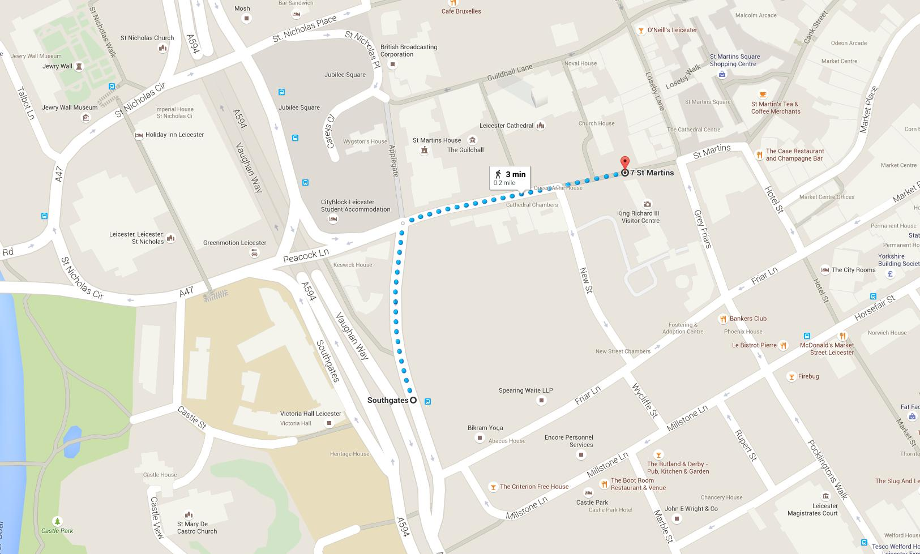
  - By Minibus
Please contact us on 0116 229 4132 or schools@kriii.com for up to date information on minibus parking in the city.

Late Arrival
If you expect that you will be late, please let us know as soon as possible by phoning us on 07534 525044

Risk Assessment
What are the hazards? | Who might be harmed and how? | What are you already doing? | Do you need to do anything else to manage this risk? | Action by whom? | Action by when? | Done
Traffic hazard on walking route from coach drop off point | School groups, coach groups | We supply a map of the walking route from the coach drop off point to the Visitor Centre and advise teachers of this on booking.  We have a recommended ratio of adults to children for school groups to ensure groups are adequately supervised.  We meet all school and coach groups at the coach drop-off point and escort them to the Visitor Centre.
Darkened gallery areas – risk of trips and falls, lost children | Visitors to KRIII, school groups | We supply a floor plan of the site to schools on booking so that accompanying adults are familiar with the route around the gallery. Gallery staff regularly move through all areas and can deal with lost children. We have a lost child policy in place.
Children running into glass doors. | Children | Glass doors and panels are marked with gold crowns at two levels to increase visibility. Staff ask children to not run around inside visitor centre and courtyard. | Monitor this and if needed, remind pupils and teachers again during their visit not to run around. | Duty managers, Gallery staff | ongoing
Slips and trips in courtyard | Spilt food and drink could make courtyard surface slippery. | Staff ask children not to run around inside visitor centre and courtyard. Spilt food to be cleaned up promptly by KRIII or café staff | Monitor this and if needed, speak to café staff about cleaning up spills quicker | Duty Managers, Gallery staff | ongoing
Glass balcony being overloaded. Max capacity is 400kg | Children, visitors | Gallery staff regularly move through all areas and can monitor number of children in this area. Groups will be instructed about safe behaviour on arrival, including a limit of how many children are permitted on the balcony at any one time. Volunteers regularly monitor this area. | Monitor this and if needed, remind pupils and teachers again during their visit about maximum number of children on balcony | Duty Managers, Gallery staff | ongoing
Slips on wet floors | Wet weather could lead to the black floors in ground floor galleries becoming slippery. | Staff to ask children not to run around inside visitor centre. Floor mats at café entrance from courtyard and black doors. | Monitor this and if needed, remind pupils and teachers again during their visit not to run around. | Duty managers, Gallery staff | ongoing
Pinch points and bottlenecks in galleries could lead to falls, crushing. | Group visits, school visits, elderly and infirm, very young - could fall and be crushed in narrower areas, particularly during emergency evacuations | Visitor numbers are controlled at entry to avoid large crowds moving through the galleries. Evacuations are guided by Gallery staff.  Teachers are given a copy of the floor plan on booking (included in this pack) and are advised to familiarise themselves with fire exit doors and routes.

COVID-19 Secure
Infection prevention | - People with symptoms are discouraged from visiting.  - All our staff, freelancers and volunteers have undergone training in the new COVID secure measures.  - We have implemented enhanced cleaning arrangements, with all frequently touched surfaces being cleaned at least three times a day. Toilets are also cleaned at least three times a day. Rooms, resources, furniture and toilets will be cleaned both before and after use by any school group.  - Doors and windows are kept open where possible to aid ventilation.  - Social distancing can be maintained within the Visitor Centre, a one-way system with signage and staff training will support this.  Staff will maintain a distance of 2m from school parties at all times, except in case of an emergency evacuation.  - Handwashing facilities, sanitiser stations, tissues and bins are available throughout the venue to help school parties maintain good hand and respiratory hygiene during their visit.  - Itineraries will be planned to allow additional time for cleaning resources and facilities between uses.  - School parties will be offered a pre-opening arrival time, to avoid contact with other visitors in the reception area and enable them to use toilet facilities
Infection control | - The Visitor Centre engages with the NHS Test and Trace system. School parties details will also be registered and retained for 21 days, as per government guidelines.

Date: Sept 2021
Conducted by: Rachel Ayrton, Learning & Interpretation Manager
Review: ongoing, no later than Sept 2022

Floor Plans (showing fire exits)
Ground Floor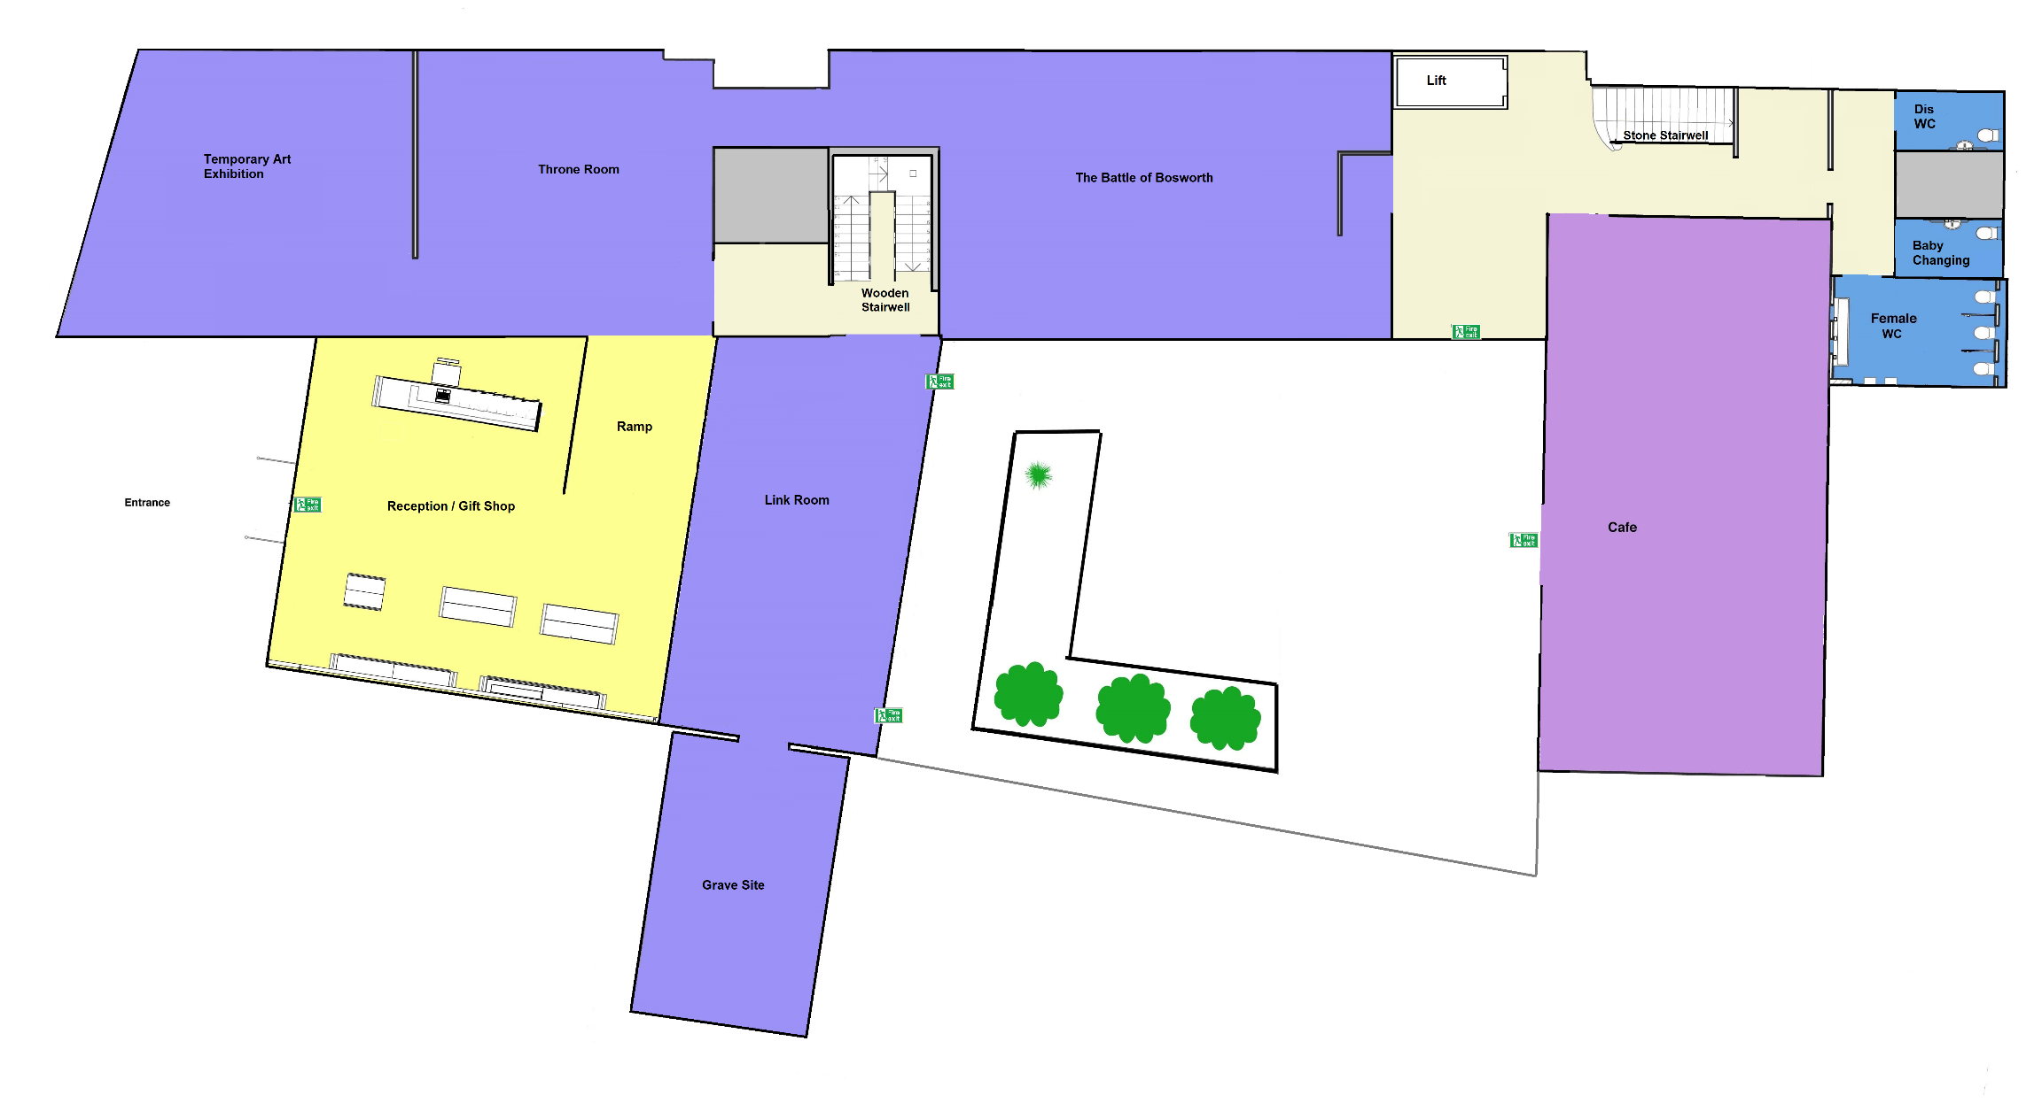
First Floor

